Mathematical Definition

🌟 Definition
# Source: AI Source: Provided by: [Data Path: Persons Table -> ID Column: 1, Name_En Column: Motasem Essam] -> From: [ChatGPT] on [5/29/2026]
A mathematical definition is a precise statement that explains the meaning of a mathematical term, concept, object, or relationship.
Definitions establish exactly what a mathematical word or symbol means, so there is no ambiguity or misunderstanding.

🎯 Purpose of Mathematical Definitions
# Source: AI Source: Provided by: [Data Path: Persons Table -> ID Column: 1, Name_En Column: Motasem Essam] -> From: [ChatGPT] on [5/29/2026]
- To give precise meanings to mathematical terms
- To create a common language for mathematicians
- To provide the foundation for theorems and proofs
- To classify and describe mathematical objects
- To ensure consistency in mathematical reasoning

📚 Characteristics of a Good Mathematical Definition
# Source: AI Source: Provided by: [Data Path: Persons Table -> ID Column: 1, Name_En Column: Motasem Essam] -> From: [ChatGPT] on [5/29/2026]
A mathematical definition should be:
- Precise — clear and exact
- Unambiguous — only one meaning
- Consistent — does not contradict other definitions
- Logical — based on previously defined concepts

🧩 Examples

Example 1: Even Number
# Source: AI Source: Provided by: [Data Path: Persons Table -> ID Column: 1, Name_En Column: Motasem Essam] -> From: [ChatGPT] on [5/29/2026]
Definition:
An even number is an integer divisible by 2.
Example:
- 2, 4, 6, 8 are even numbers.

Example 2: Triangle
# Source: AI Source: Provided by: [Data Path: Persons Table -> ID Column: 1, Name_En Column: Motasem Essam] -> From: [ChatGPT] on [5/29/2026]
Definition:
A triangle is a polygon with three sides and three angles.

Example 3: Prime Number
# Source: AI Source: Provided by: [Data Path: Persons Table -> ID Column: 1, Name_En Column: Motasem Essam] -> From: [ChatGPT] on [5/29/2026]
Definition:
A prime number is a natural number greater than 1 that has exactly two positive divisors: 1 and itself.
Examples:
- 2, 3, 5, 7, 11

Example 4: Function
# Source: AI Source: Provided by: [Data Path: Persons Table -> ID Column: 1, Name_En Column: Motasem Essam] -> From: [ChatGPT] on [5/29/2026]
Definition:
A function is a relation that assigns exactly one output to each input.
Example:
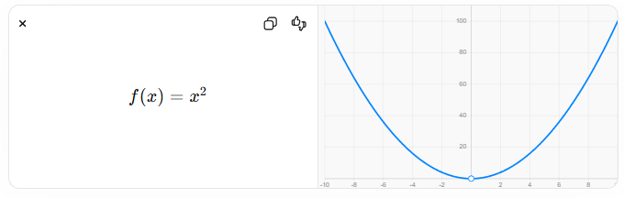
$$f(x)=x^{2}$$

🔗 Relationship to Other Mathematical Concepts
# Source: AI Source: Provided by: [Data Path: Persons Table -> ID Column: 1, Name_En Column: Motasem Essam] -> From: [ChatGPT] on [5/29/2026]
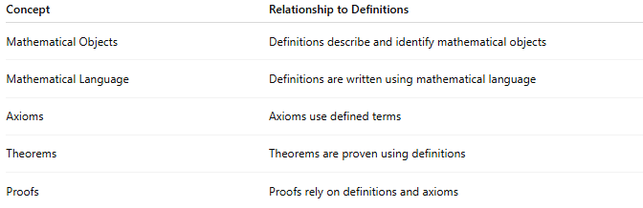
Concept | Relationship to Definitions
Mathematical Objects | Definitions describe and identify mathematical objects
Mathematical Language | Definitions are written using mathematical language
Axioms | Axioms use defined terms
Theorems | Theorems are proven using definitions
Proofs | Proofs rely on definitions and axioms

📖 Definition vs. Axiom vs. Theorem
# Source: AI Source: Provided by: [Data Path: Persons Table -> ID Column: 1, Name_En Column: Motasem Essam] -> From: [ChatGPT] on [5/29/2026]
Concept | Meaning
Definition | Explains what a term means
Axiom | Accepted statement without proof
Theorem | Statement proven using definitions, axioms, and logic
Example
Definition:
A square is a quadrilateral with four equal sides and four right angles.
Axiom:
Things equal to the same thing are equal to each other.
Theorem:
The diagonals of a square are equal in length.

🧭 Summary
# Source: AI Source: Provided by: [Data Path: Persons Table -> ID Column: 1, Name_En Column: Motasem Essam] -> From: [ChatGPT] on [5/29/2026]
A mathematical definition is a precise explanation of a mathematical concept, object, or term. Definitions are the building blocks of mathematics because they provide the meanings needed to formulate axioms, prove theorems, and communicate mathematical ideas accurately.

